Антон Желомский, 39-я кагорта, 4-й спринт

# **Консоль**

## Задание 1

Команда или последовательность команд, которой удалось получить нужные логи:

grep -R "^233.201.*" ~/logs/2019/12

Логи:

/home/morty/logs/2019/12/apache_2019-12-18.txt:233.201.188.154 - - [18/12/2019:21:46:01 +0000] "DELETE /events HTTP/1.1" 403 3971

/home/morty/logs/2019/12/apache_2019-12-21.txt:233.201.182.9 - - [21/12/2019:21:56:20 +0000] "PATCH /users HTTP/1.1" 400 4118

## Задание 2

Команды, которые создают директории bug1 и events:

mkdir ~/bug1

mkdir ~/bug1/events

Команда, которой выбираешь запросы за указанный период. Это те запросы, которыми ты отбираешь логи в файл main.txt:

grep "30/12/2019:21:3.:..* [45]00 " ~/logs/2019/12/apache_2019-12-30.txt > ~/bug1/main.txt

grep "31/12/2019:21:3.:..* [45]00 " ~/logs/2019/12/apache_2019-12-31.txt >> ~/bug1/main.txt

Команды, которыми ты кладёшь логи в файлы 400.txt и 500.txt из main.txt:

grep " 400 " ~/bug1/main.txt > ~/bug1/events/400.txt

grep " 500 " ~/bug1/main.txt > ~/bug1/events/500.txt

400.txt  
80.57.170.51 - - [30/12/2019:21:35:12 +0000] "DELETE /users HTTP/1.1" 400 3623

204.235.176.118 - - [30/12/2019:21:35:13 +0000] "POST /users HTTP/1.1" 400 4704

82.95.203.67 - - [30/12/2019:21:35:19 +0000] "DELETE /lists HTTP/1.1" 400 3737

155.242.215.46 - - [30/12/2019:21:35:38 +0000] "POST /playbooks HTTP/1.1" 400 4450

189.176.85.0 - - [30/12/2019:21:35:39 +0000] "PATCH /alerts HTTP/1.1" 400 2732

13.108.71.71 - - [30/12/2019:21:35:43 +0000] "PATCH /events HTTP/1.1" 400 3410

195.213.133.182 - - [30/12/2019:21:35:46 +0000] "PUT /customers HTTP/1.1" 400 3085

235.243.133.78 - - [30/12/2019:21:35:47 +0000] "PATCH /customers HTTP/1.1" 400 3264

192.57.115.49 - - [30/12/2019:21:35:55 +0000] "POST /parsers HTTP/1.1" 400 2457

71.0.49.244 - - [30/12/2019:21:35:55 +0000] "PUT /collectors HTTP/1.1" 400 2785

224.159.206.126 - - [30/12/2019:21:36:02 +0000] "DELETE /customers HTTP/1.1" 400 4569

131.35.106.246 - - [30/12/2019:21:36:04 +0000] "DELETE /lists HTTP/1.1" 400 2578

216.24.42.208 - - [30/12/2019:21:36:06 +0000] "GET /parsers HTTP/1.1" 400 4597

123.53.150.160 - - [30/12/2019:21:37:19 +0000] "PATCH /events HTTP/1.1" 400 4379

61.129.127.103 - - [30/12/2019:21:37:32 +0000] "GET /lists HTTP/1.1" 400 2575

90.216.4.78 - - [30/12/2019:21:37:34 +0000] "PATCH /lists HTTP/1.1" 400 3899

204.250.214.208 - - [30/12/2019:21:37:36 +0000] "PATCH /parsers HTTP/1.1" 400 4742

79.214.240.98 - - [30/12/2019:21:37:37 +0000] "POST /fieldsets HTTP/1.1" 400 4441

65.47.42.12 - - [30/12/2019:21:37:39 +0000] "PATCH /customers HTTP/1.1" 400 2500

251.118.141.34 - - [30/12/2019:21:37:41 +0000] "POST /customers HTTP/1.1" 400 3519

205.20.166.196 - - [30/12/2019:21:37:51 +0000] "POST /users HTTP/1.1" 400 4032

156.217.3.46 - - [30/12/2019:21:37:52 +0000] "PATCH /parsers HTTP/1.1" 400 2020

48.240.198.167 - - [30/12/2019:21:37:57 +0000] "PATCH /playbooks HTTP/1.1" 400 4100

101.255.159.211 - - [30/12/2019:21:37:59 +0000] "GET /auth HTTP/1.1" 400 2324

80.76.98.203 - - [30/12/2019:21:38:00 +0000] "POST /playbooks HTTP/1.1" 400 3045

85.64.63.255 - - [30/12/2019:21:38:13 +0000] "PATCH /collectors HTTP/1.1" 400 2291

184.79.247.161 - - [30/12/2019:21:38:13 +0000] "PUT /alerts HTTP/1.1" 400 3557

93.2.134.22 - - [30/12/2019:21:39:39 +0000] "DELETE /alerts HTTP/1.1" 400 3701

86.34.86.182 - - [31/12/2019:21:35:10 +0000] "POST /auth HTTP/1.1" 400 3626

167.37.16.117 - - [31/12/2019:21:35:17 +0000] "PATCH /customers HTTP/1.1" 400 3294

199.128.92.19 - - [31/12/2019:21:35:43 +0000] "PUT /users HTTP/1.1" 400 4180

162.152.99.143 - - [31/12/2019:21:35:59 +0000] "PUT /users HTTP/1.1" 400 4606

83.115.59.224 - - [31/12/2019:21:37:26 +0000] "GET /alerts HTTP/1.1" 400 3489

194.10.97.226 - - [31/12/2019:21:37:31 +0000] "DELETE /lists HTTP/1.1" 400 2447

180.99.214.40 - - [31/12/2019:21:37:44 +0000] "DELETE /alerts HTTP/1.1" 400 2077

154.152.205.4 - - [31/12/2019:21:37:50 +0000] "GET /playbooks HTTP/1.1" 400 3324

197.82.125.54 - - [31/12/2019:21:37:52 +0000] "PUT /fieldsets HTTP/1.1" 400 4365

115.89.87.219 - - [31/12/2019:21:38:06 +0000] "PUT /playbooks HTTP/1.1" 400 2589

100.77.15.14 - - [31/12/2019:21:38:07 +0000] "GET /fieldsets HTTP/1.1" 400 4911

22.33.159.242 - - [31/12/2019:21:38:07 +0000] "GET /playbooks HTTP/1.1" 400 3955

149.148.229.11 - - [31/12/2019:21:39:16 +0000] "GET /users HTTP/1.1" 400 2071

236.107.64.192 - - [31/12/2019:21:39:17 +0000] "PATCH /users HTTP/1.1" 400 2791

24.156.105.39 - - [31/12/2019:21:39:23 +0000] "GET /lists HTTP/1.1" 400 2902

193.50.164.254 - - [31/12/2019:21:39:23 +0000] "PUT /playbooks HTTP/1.1" 400 3296

18.123.104.91 - - [31/12/2019:21:39:52 +0000] "GET /collectors HTTP/1.1" 400 4372

234.218.148.4 - - [31/12/2019:21:39:54 +0000] "PUT /users HTTP/1.1" 400 2509

500.txt.

64.250.112.189 - - [30/12/2019:21:35:13 +0000] "PUT /parsers HTTP/1.1" 500 4639

193.253.101.180 - - [30/12/2019:21:35:31 +0000] "PATCH /alerts HTTP/1.1" 500 2944

197.106.117.194 - - [30/12/2019:21:35:31 +0000] "PATCH /parsers HTTP/1.1" 500 3519

247.124.71.67 - - [30/12/2019:21:35:45 +0000] "PUT /alerts HTTP/1.1" 500 2746

62.88.204.119 - - [30/12/2019:21:35:51 +0000] "PUT /auth HTTP/1.1" 500 2666

125.156.142.26 - - [30/12/2019:21:36:01 +0000] "PATCH /events HTTP/1.1" 500 3460

144.170.212.70 - - [30/12/2019:21:36:04 +0000] "DELETE /parsers HTTP/1.1" 500 2599

59.39.200.252 - - [30/12/2019:21:36:05 +0000] "GET /alerts HTTP/1.1" 500 2650

150.136.200.100 - - [30/12/2019:21:37:24 +0000] "POST /lists HTTP/1.1" 500 2684

84.81.25.45 - - [30/12/2019:21:37:25 +0000] "POST /auth HTTP/1.1" 500 2052

30.222.160.141 - - [30/12/2019:21:37:30 +0000] "PATCH /parsers HTTP/1.1" 500 2017

117.87.158.36 - - [30/12/2019:21:37:34 +0000] "POST /fieldsets HTTP/1.1" 500 4056

212.153.128.212 - - [30/12/2019:21:37:42 +0000] "PUT /fieldsets HTTP/1.1" 500 3259

58.188.83.217 - - [30/12/2019:21:37:46 +0000] "POST /playbooks HTTP/1.1" 500 3947

193.123.131.146 - - [30/12/2019:21:37:47 +0000] "PUT /lists HTTP/1.1" 500 3902

182.7.179.91 - - [30/12/2019:21:37:48 +0000] "GET /users HTTP/1.1" 500 2950

10.25.168.164 - - [30/12/2019:21:38:05 +0000] "PATCH /playbooks HTTP/1.1" 500 3858

215.201.210.173 - - [30/12/2019:21:38:11 +0000] "PATCH /customers HTTP/1.1" 500 3277

179.241.103.167 - - [30/12/2019:21:39:23 +0000] "POST /lists HTTP/1.1" 500 3669

147.188.170.252 - - [30/12/2019:21:39:33 +0000] "POST /fieldsets HTTP/1.1" 500 3313

1.249.123.189 - - [30/12/2019:21:39:36 +0000] "PATCH /alerts HTTP/1.1" 500 4734

124.114.135.105 - - [30/12/2019:21:39:41 +0000] "PATCH /customers HTTP/1.1" 500 3348

35.215.100.202 - - [30/12/2019:21:39:43 +0000] "PUT /alerts HTTP/1.1" 500 4345

86.222.23.128 - - [30/12/2019:21:39:44 +0000] "PATCH /alerts HTTP/1.1" 500 2230

20.161.75.95 - - [30/12/2019:21:39:48 +0000] "DELETE /users HTTP/1.1" 500 2412

196.18.151.117 - - [30/12/2019:21:39:55 +0000] "PUT /events HTTP/1.1" 500 4439

77.101.138.151 - - [30/12/2019:21:39:57 +0000] "PUT /lists HTTP/1.1" 500 2194

208.205.133.127 - - [31/12/2019:21:35:17 +0000] "DELETE /alerts HTTP/1.1" 500 4561

20.145.255.91 - - [31/12/2019:21:35:30 +0000] "GET /parsers HTTP/1.1" 500 3051

91.66.134.13 - - [31/12/2019:21:35:53 +0000] "POST /lists HTTP/1.1" 500 3319

31.88.211.206 - - [31/12/2019:21:35:57 +0000] "DELETE /events HTTP/1.1" 500 2325

171.37.114.114 - - [31/12/2019:21:37:39 +0000] "DELETE /fieldsets HTTP/1.1" 500 3253

223.157.242.167 - - [31/12/2019:21:37:59 +0000] "POST /users HTTP/1.1" 500 2283

98.181.102.34 - - [31/12/2019:21:38:06 +0000] "PATCH /fieldsets HTTP/1.1" 500 4672

254.74.22.79 - - [31/12/2019:21:38:06 +0000] "PUT /lists HTTP/1.1" 500 2259

103.46.238.3 - - [31/12/2019:21:38:09 +0000] "PUT /lists HTTP/1.1" 500 3992

41.62.205.107 - - [31/12/2019:21:39:20 +0000] "PATCH /alerts HTTP/1.1" 500 3631

22.53.105.197 - - [31/12/2019:21:39:31 +0000] "DELETE /collectors HTTP/1.1" 500 4202

178.22.133.42 - - [31/12/2019:21:39:43 +0000] "PUT /alerts HTTP/1.1" 500 4648

102.247.13.50 - - [31/12/2019:21:39:55 +0000] "PATCH /auth HTTP/1.1" 500 3736

# **База данных**

## Задание 1

Число автомобилей:

5500

Запрос, которым тебе удалось решить задачу.

SELECT COUNT(DISTINCT vehicle_id) AS vehicle_cnt FROM cabs;

## Задание 2

Список компаний с числом автомобилей меньше 100.

Nova Taxi Affiliation Llc

Patriot Taxi Dba Peace Taxi Associat

Blue Diamond

Checker Taxi Affiliation

Chicago Medallion Management

Chicago Independents

24 Seven Taxi

Checker Taxi

American United

Chicago Medallion Leasing INC

Top Cab Affiliation

KOAM Taxi Association

Chicago Taxicab

Norshore Cab

Gold Coast Taxi

Metro Group

Service Taxi Association

5 Star Taxi

American United Taxi Affiliation

Metro Jet Taxi A

Setare Inc

Leonard Cab Co

0118 - 42111 Godfrey S.Awir

1085 - 72312 N and W Cab Co

1469 - 64126 Omar Jada

2092 - 61288 Sbeih company

2192 - 73487 Zeymane Corp

2241 - 44667 - Felman Corp, Manuel Alonso

2733 - 74600 Benny Jona

2809 - 95474 C & D Cab Co Inc.

2823 - 73307 Lee Express Inc

3011 - 66308 JBL Cab Inc.

3094 - 24059 G.L.B. Cab Co

3556 - 36214 RC Andrews Cab

3591 - 63480 Chuks Cab

3620 - 52292 David K. Cab Corp.

3623 - 72222 Arrington Enterprises

3721 - Santamaria Express, Alvaro Santamaria

4053 - 40193 Adwar H. Nikola

4615 - 83503 Tyrone Henderson

4623 - 27290 Jay Kim

5006 - 39261 Salifu Bawa

5062 - 34841 Sam Mestas

5074 - 54002 Ahzmi Inc

5874 - 73628 Sergey Cab Corp.

5997 - 65283 AW Services Inc.

6057 - 24657 Richard Addo

6574 - Babylon Express Inc.

6742 - 83735 Tasha ride inc

6743 - 78771 Luhak Corp

Chicago Star Taxicab

Запрос, которым тебе удалось решить задачу.

SELECT DISTINCT company_name AS company_name, COUNT(*) AS cnt FROM cabs GROUP BY company_name HAVING COUNT(*) < 100 ORDER BY cnt DESC;

## Задание 3

Таблица с данными за указанный период.

Ссылки на картинку:

<https://drive.google.com/file/d/1O8xn_ZxLPielsAVy1yfnVQr9QpG179wx/view?usp=sharing>

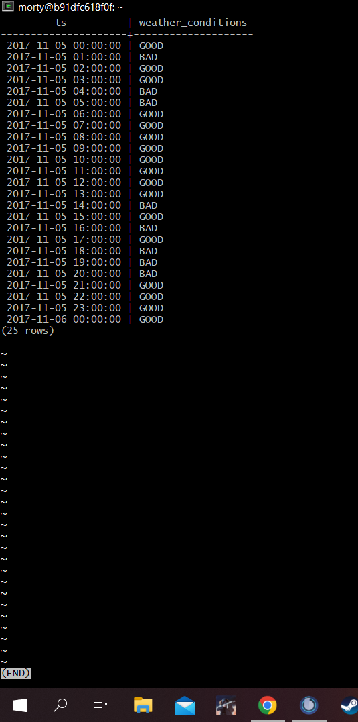

Запрос, которым удалось решить задачу.

SELECT ts, CASE WHEN description LIKE '%rain%' THEN 'BAD' WHEN description LIKE '%storm%' THEN 'BAD' ELSE 'GOOD' END AS weather_conditions FROM weather_records WHERE ts BETWEEN '2017-11-05%' AND '2017-11-06 00:%';

## Задание 4

Таблица с данными за указанный период.

Ссылки на картинку:

<https://drive.google.com/file/d/1DmeXickfCDQXx--GZwzjNUmDB8rhvw3a/view?usp=sharing>

<https://i.imgur.com/YA7WnWn.png>

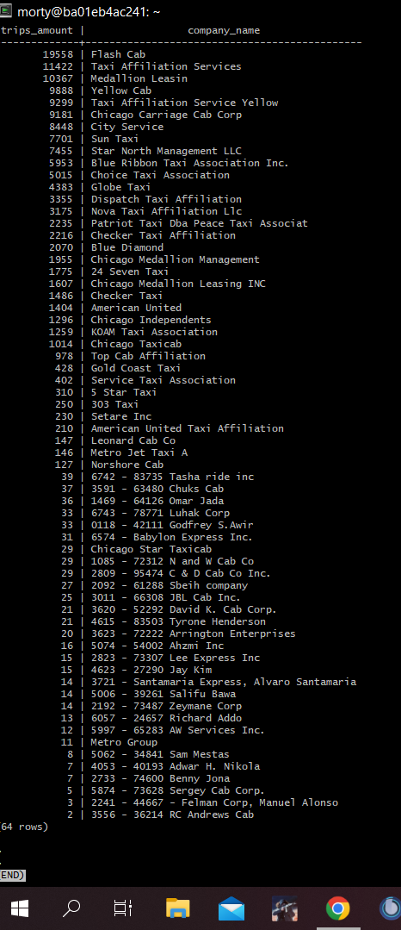

Запрос, которым удалось решить задачу.

SELECT COUNT(trips.trip_id) AS trips_amount, cabs.company_name AS company_name FROM trips INNER JOIN cabs ON cabs.cab_id = trips.cab_id WHERE start_ts::date = '2017-11-15%' OR start_ts::date = '2017-11-16%' GROUP BY company_name ORDER by trips_amount DESC;